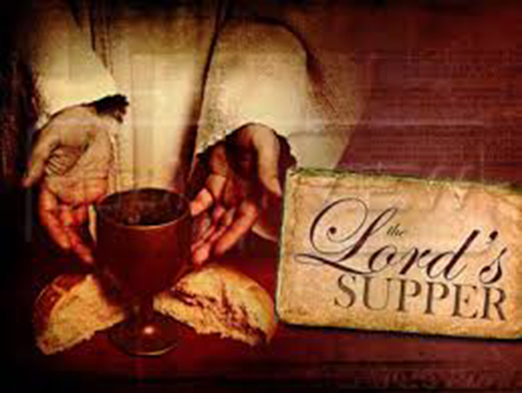
This Photo by Unknown Author is licensed under CC BY-NC-ND

BIBLE STUDY SERIES: PROBLEMS IN THE CHURCH
PROBLEM #4 – Wrong Conduct at the Lord’s Supper
FIRST CORINTHIANS 11:17-34
TUESDAY, SEPTEMBER 28, 2021
Growing in The Word Bible Study via Zoom
Access Code: 362 296 9704 – Password 840101
PROVIDENCE M.B. CHURCH
8401 S. ASHLAND AVENUE
CHICAGO IL 60620
Tuesday 6:00 PM-7:00 PM

Rev. Dr. William H. Foster, Jr., Senior Pastor
Dr. Dolly A. Robinson, Instructor

Group Discussion: Even though we do not live in the same environment as the church at Corinth, do you think there are still irregularities when it comes to the Lord’s Supper.
INTRODUCTION:
One writer has said “The Lord Supper is the highest expression and the holiest exercise of Christian worship.” However, in Corinth it had dropped to such a low secular level that Paul found it necessary to abruptly leave the topic about head coverings (11:1-16) and begin a totally different teaching relating to the Lord’s Supper. He had apparently received a report that there were divisions and inequalities when the Corinthian Christians came together to have a fellowship meal which was followed by the Lord’s Supper. We do not have a fellowship meal today before taking communion. Even though this is not a common practice for us, there are still irregularities when we come together for communion. As we look at the text tonight, we want to reiterate the seriousness of observing the Lord’s Supper and really consider our self-examination before taking communion.

LESSON OUTLINE
Wrong Conduct at the Lord’s Supper
1st Corinthians 11:17-34

I Wrong Conduct – 1st Corinthians 11:17-22
- The Apostle’s stern condemnation – vs. 17-19
- The wrong motives – vs. 20-21
- The wrong attitude toward others – v. 22

II The Command from the Lord – 1st Corinthians 11:23-26
- The Apostle’s direct revelation – v. 23
- The message from the Lord – vs. 24-26

III Beware of Condemnation – 1st Corinthians 11:27-34
- Warning regarding wrong conduct – v. 11:27
- Conduct a self-examination – vs. 28-29
- Results of wrong conduct – vs. 30-32
- Final Instructions – vs. 33-34

Food for Thought: Make sure you take your self-exam before you take the Lord’s Supper

Coming Up Next: We will return to our regularly scheduled topic:
Put Other First – 1st Corinthians 10:23-33

